**Text Mining POC**

**Implementation:**

Applied Text Mining to identify customer satisfaction on the POCO M3 mobile in the customer reviews on the amazon site.

**Data Source:** customer reviewsinamazon site for **POCO M3**.

**Word Cloud Generated:**

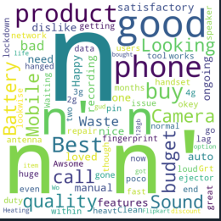

**Analysis:**

Please find my below observation points from the word cloud analysis:

* Ignore ***n*** from the image because it is new line command which was an issue in the dataset.
* The size of the word will denotes that how much time the word has been repeated in the dataset.
* We can understand that most of the people commented as good,awesome and satisfactory.
* We can also see some are commented as Waste.